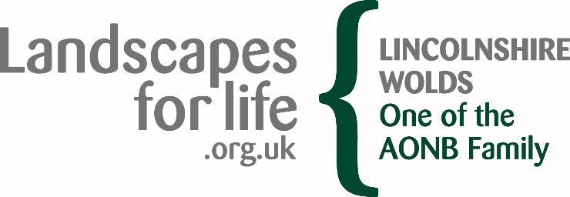
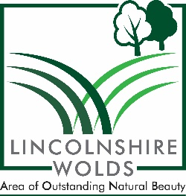

Balloon and sky lantern releases in the Lincolnshire Wolds Area of Outstanding Natural Beauty (AONB)
Introduction
Areas of Outstanding Natural Beauty (AONBs) are designated by the Government for the purpose of ensuring that the natural beauty of the finest landscapes in England and Wales is conserved and enhanced. The AONB produces occasional position statements outlining its position on specific issues.
Purpose
This Position Statement, endorsed by the Lincolnshire Wolds AONB Joint Advisory Committee (JAC), provides the view of the Partnership to local planning authorities, landowners, residents and others interested in the Lincolnshire Wolds AONB.
Background
The Lincolnshire Wolds AONB Management Plan 2018-24 Policy PP8 states:
To support general waste reduction measures and recycling initiatives that are in accordance with the special requirements of the AONB and help shift towards a circular economy.
Position
It is considered by the Partnership that balloon and sky lantern releases have the potential to adversely impact upon the special qualities of the area and are therefore not supported and wherever possible, are actively discouraged by the Partnership.
The Partnership takes this position as:
1. There is a risk of harm to wildlife and livestock (ingestion, entanglement, entrapment, panic) from released balloons and sky lanterns.
2. There is a risk from sky lanterns by causing fires on an industrial scale; destroying acres of crops, farm and thatched buildings and stored food supplies, alongside killing or injuring farm animals.
3. Both contribute to the defacement of land by litter and waste and incur clean-up costs.

Views from other organisations
The National Fire Chiefs Council has issued a position statement that it does not support the use of sky lanterns and balloons and asks members of the public and event organisers to refrain from using them. In addition the National Farmers’ Union, Women’s Farmers Union, Marine Conservation Society, Country Land and Business Association, RSPCA, RSPB, Master Thatchers, Wildlife Trusts and Keep Britain Tidy are amongst those who have called for a ban or urge individuals to use alternatives to sky lanterns and to ask event planners and retailers to use alternatives as well.
County, Unitary and District Councils often have policies to ban balloon and sky lantern releases from their land or do not support the release of balloons or sky lanterns, see authority websites for up to date position.
For further information
Contact the Lincolnshire Wolds Countryside Service on 01522 555780 or aonb@lincswolds.org.uk
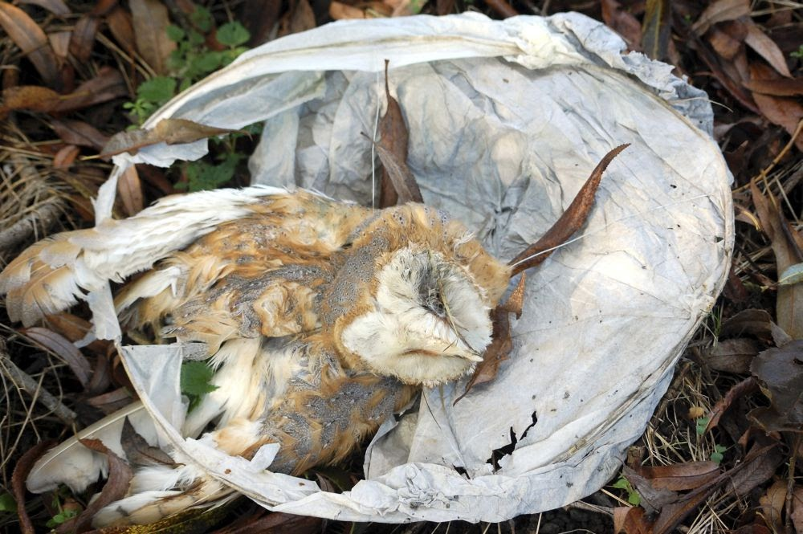

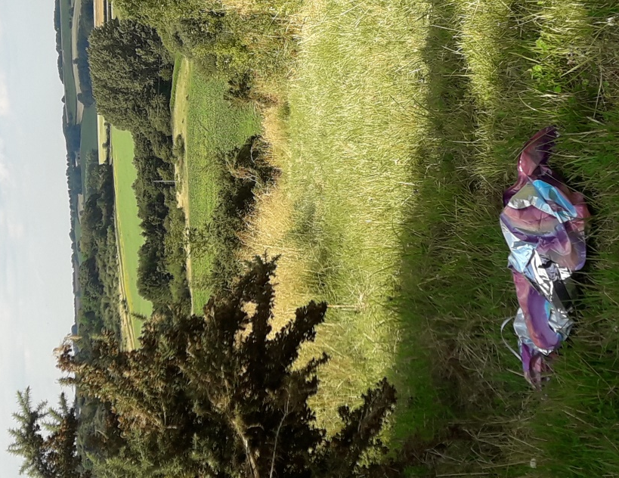
Sky lanterns can cause death and injury to wildlife.

Helium balloons can travel miles before coming down,
in this instance in a field with cattle in.

